S3 VERSIONING OVERVIEW
- You can version your file in S3
- Versioning is done at the bucket level
- Same key overwrite will change the ‘version’:1,2,3..
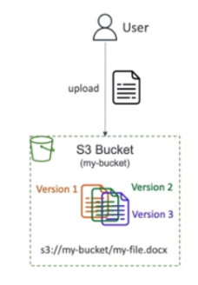
- It is best practice to version your buckets
- Protect against unintended deletes (ability to restore a version)
- Easy rollback to previous version
- NOTES:
- Any file that is not versioned prior to enabling version will have the version – “null”
- Suspending versioning doesn’t delete the previous versions.

Enabling S3 Versioning
- Go to your bucket and then to its properties tab
- Enable the bucket versioning settings
- Enable the versioning key toggle
- Deleting an original file will not actually delete it. It will be versioned as “delete marker”. You will have to delete this version again from the console.

